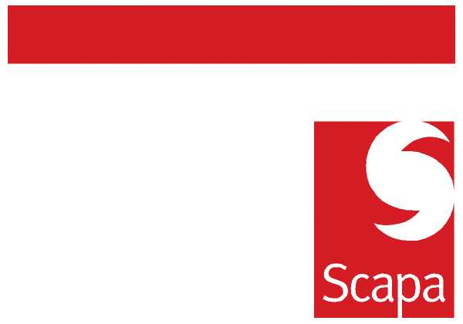

12th August 2010

GROUP AUTHORITY MATRIX AND CONTROL STANDARDS
A number of previous communications have referenced the importance of ensuring that we continually develop our Processes, improving standardisation and general efficiency.
Following a period of consultation a new Group Authority Matrix has been developed. The new Matrix is an important element of Scapa’s overall process and control framework and reflects the Group’s latest organisational structures. The new Matrix should be applied across the Group with immediate effect.
In conjunction with the update of the Matrix we are also launching an extension of the existing Finance Minimum Control Standards to cover core business control processes from a Commercial and Operations functional perspective. These must now be observed at our European and North American locations. We will look to extend the Standards into Asia as the business develops.
Against key control objectives the Standards specify the controls which must be followed, defining aspects such as the frequency and accountability for completion of the control. The Group Authority Matrix and Control Standards set clear expectations in terms of control obligations
The new Authority Matrix and support Standards can be located on the Intranet under the Document tab and Minimum Control Standards menu item.
Compliance with the Matrix and existing Standards is already assessed during a programme of Finance team internal audits managed by our Group Risk and Assurance function. These audits will be extended next year to cover the new Standards as they relate to other functional areas.
If you have any questions please direct these to Matt Fowler or Andrew Monkhouse.

Brian Tenner
Group Finance Director

